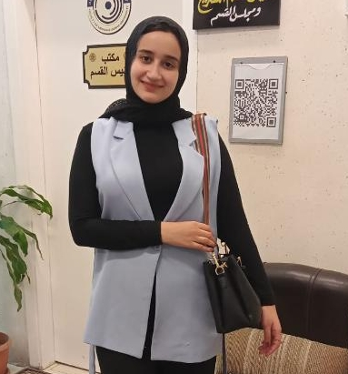 |  | esraa mohamed hassan  Assistant Lecturer At Anatomy& Embryology Department
Profile  30y-mother and wify hijabi doctor  Contact  PHONE:  +2001015840944  WEBSITE:  https://www.facebook.com/esraa.mohammed.92123015  https://www.instagram.com/sostiy?igsh=MTlweTNhdXI3NmppeA==  EMAIL: esraa.hasan@fmed.bu.edu.eg  Hobbies  Swimming  Singing  Doing sports  Watching k-dramas  Fashion blogging |  | EDUCATION  BACHELOR OF MEDICINE AND SURGERY at 2019 (94.24%)  BENHA FACULTY OF MEDICINE  MASTER’S DEGREE IN ANATOMY AND EMBRYOLOGY at 2025  BENHA FACULTY OF MEDICINE  WORK EXPERIENCE  Administrator of Anatomy& Embryology (2019-2025)  BENHA FACULTY OF MEDICINE& BENHA FACULTY OF NURSING& BENHA FACULTY OF PHYSICAL THERAPY  Assistant lecturer of anatomy& embryology (2025)  Benha FACULTY OF MEDICINE& BENHA FACULTY OF NURSING& BENHA FACULT OF PHYSICAL THERAPY& MENOUF FACULTY OF NURSING  Medical Research Assistant (2024-2025)  Local Medical Research Office  SKILLS  Cadaveric dissection  Research assessment  Publication writing & peer review (already published one at benha medicl journal under name of (The Possible Protective Role Of Pomegranate Peel Extract On Thyroid Toxicity Induced By Semicarbazide; Hormal, Histological And Immunohistochemical Study)  Microscopic examination  Computer skills (word- power point- excel- end note)  Perfect Communication & presentation skills  Positivity  Driving & dealing with paper printers

